Fully Dressed UC2:

Player Builds Structures

High Business Value

# 

# Table of Contents

**Table of Contents** **1**

**Use Case:** **2**

**Scope:** **2**

**Level:** **2**

**Primary Actor:** **2**

**Preconditions:** **2**

**Stakeholders and Interests:** **2**

**Success Guarantee:** **2**

**Main Success Scenario:** **2**

**Extensions:** **3**

**Special Requirements:** **3**

**Technology and Data Variations List:** **3**

**Frequency of Occurrence:** **3**

**Miscellaneous:** **3**

**System Sequence Diagram** **4**

**Scenario Extension** **5**

*highlights indicate changes

# Use Case:

Player Builds Structures

# 

# Scope:

City Builder Game Application

# 

# Level:

user-goal

# 

# Primary Actor:

Player

# 

# Preconditions:

System is running, Players are logged in, is at the system, can input into the system, and has enough resources.

# 

# Stakeholders and Interests:

Players- If the player is not able to build a structure, they cannot fully complete their turn, or gain a point in any way.

Administrator- The administrator needs to check if the users got the appropriate resources when the player decides to choose to build a structure.

Developers- need to make sure that the appropriate resources are assigned to the named actions visible by the players. They also need to evaluate the amount of points a certain structure gives, and that a structure is capable of being built in the world this game takes place. Not every building imaginable is capable of being built with separate ID and statistics assigned. There is a limit given to the portfolio of structures to choose from to build.

Evaluator- We get graded on if the project works, and this helps the project work

# 

# Success Guarantee:

When player takes their turn to perform the action of building a structure they have greater than or equal to the amount of materials needed to build a structure.

# 

# Main Success Scenario:

Administrator starts the system

Players are logged in and authenticated

Player gathers resources and passes to next player

Player takes action to build a structure.

System checks for enough resources gathered by player who wants to build.

System verifies player has enough resources to build the structure.

System authenticates amount of resources and rewards with points and structure.

Player gets new building and points.

Player ends turn.

Next player takes a turn.

# Extensions:

* Player is not able to build a structure where the other player has already built on a certain property.
* On a player’s turn, player wants to build structure despite no available space.
  + Player uses action to destroy/take resources used on that building.
    - Player gains at most 1 point for resources used to destroy structure.
      * Player has the option to now use the right amount of resources to build their structure on that open property.
    - System takes away a point from the player that had their structure destroyed.

# Special Requirements:

* System shows updated resources within 5 seconds of the gather action being taken
* System works in both Linux and C++
* Shows all options in English

# 

# Technology and Data Variations List:

* System Administrator Override by entering user name and password

# Frequency of Occurrence:

* Occurs in practically every other, if not every turn. Most crucial action needed to win game.

# 

# Miscellaneous:

What are the structure capacity?

Can a player take the same action more than once?

When can a player not take back their action?

Can a structure be worth more than another?

If there a structure limit on the world?

# 

# 

# 

# 

# 

# System Sequence Diagram

In this scenario, the player will login into the system. The system will successfully authenticate the player, and the player will start the game. The player(s) will take turns gathering resources. When the player(s) are able to start building, the player(s) will use buildBuilding(cost, pointvalue) to build their buildings. The system will then use updatePoints() for the player and display the successful building with displayBuilding(). In this iteration, the login is uncompleted and is very basic at this point. We plan to add cancelBuilding() to allow a player to cancel building, and we also plan to add different buildings since at this point we only have one building.

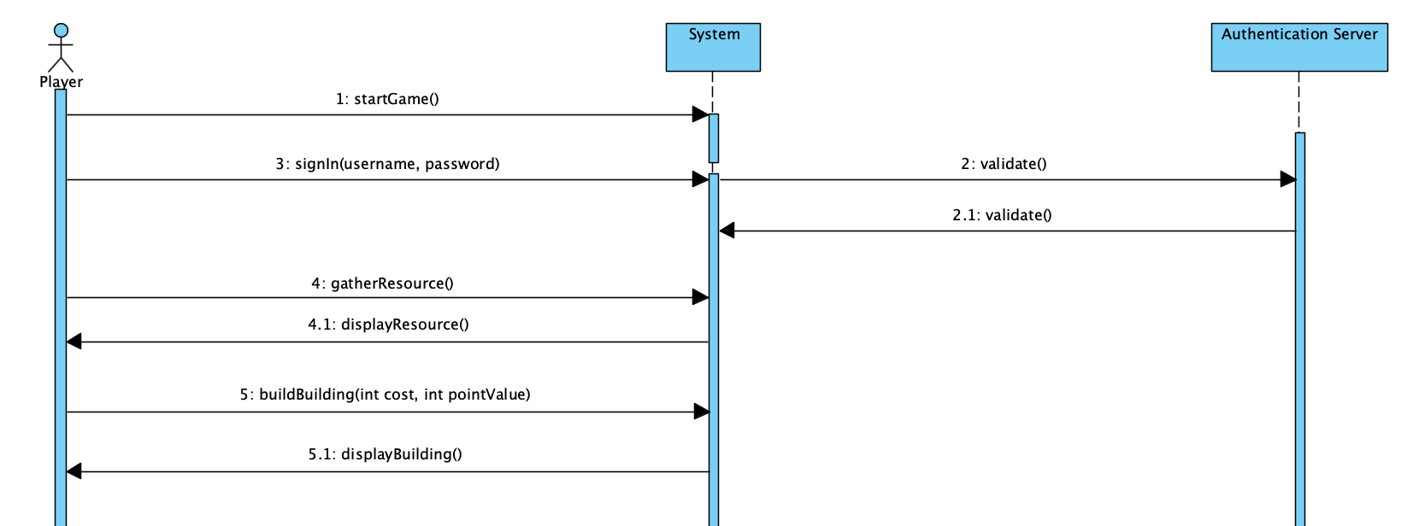

# Scenario Extension



As an extension to the above scenario, we have added different buildings to be built in the system. A player can now build a house, a school, a skyscraper, and a bridge. This will allow our users to have a varied experience because they will be able to play a different game with different strategies each time. All commands remain the same, except for when they would like to build a building they will be able to select which type they want, and the resources will be taken from them and proper points assigned. In reference to the above SSD, all that will change is the buildBuilding (cost and pointValue).